**Clinical Decision Support (CDS) Content and Health Level 7 (HL7)-Compliant Knowledge Artifacts (KNARTs)**

**Primary Care: General Clinical Note - History and Physical Exam Clinical Content White Paper**

**Department of Veterans Affairs (VA)**



**Knowledge Based Systems (KBS)**

**Office of Informatics and Information Governance (OIIG)**

**Clinical Decision Support (CDS)**

**Clinical Decision Support (CDS) Content and Health Level 7 (HL7)-Compliant Knowledge Artifacts (KNARTs): Primary Care: General Clinical Note - History and Physical Exam Clinical Content White Paper**

by Department of Veterans Affairs (VA)

Publication date April 2018

**Contract: VA118-16-D-1008, Task Order (TO): VA-118-16-F-1008-0007**

**Table 1. Relevant KNART Information: Primary Care: General Clinical Note - History and Physical Exam**

| **Primary Care KNART** | **Associated CLIN** |
| --- | --- |
| General Clinical Note - History and Physical Exam - Documentation Template | CLIN0009CA |

**Table of Contents**

VA Subject Matter Expert (SME) Panel vi

Introduction vii

Conventions Used ix

1. Primary Care: General Clinical Note – History and Physical Exam 1

1.1. Clinical Context 1

1.2. Knowledge Artifacts 1

2. Primary Care: General Clinical Note - History and Physical Exam Documentation Template 2

2.1. Knowledge Narrative 2

2.2. General Clinical Note 2

2.2.1. Demographics 2

2.2.2. History 3

2.2.3. Screening 6

2.2.4. Physical Examination 7

2.2.5. Assessment and Plan 8

Bibliography/Evidence 10

A. Existing Sample VA Artifacts 11

B. Basic Laboratory Panel Definition 54

Acronyms 55

**List of Figures**

A.1. VA National Primary Care Note Template: VA Primary Care New Patient - Visit/Chief Complaint and Past History Sections 11

A.2. VA National Primary Care Note Template: VA Primary Care New Patient - Female Gender Specific History and Social History Section 12

A.3. VA National Primary Care Note Template: VA Primary Care New Patient - Marital/Domestic Status Section 13

A.4. VA National Primary Care Note Template: VA Primary Care New Patient - Marital/Domestic Status, Social History and Military History (Branch of Service) 14

A.5. VA National Primary Care Note Template: VA Primary Care New Patient - Marital/Domestic Status, Social History and Military History Sections (Period of Service) 15

A.6. VA National Primary Care Note Template: VA Primary Care New Patient - Marital/Domestic Status, Social History, Military History and Screen for Physical/Psychological/Sexual Abuse Sections 16

A.7. VA National Primary Care Note Template: VA Primary Care New Patient - Allergies as Displayed in VistA, Medications, Over the Counter (OTC) or Non-VA Prescription Medications, and Family History Sections 17

A.8. VA National Primary Care Note Template: VA Primary Care New Patient - Review of Systems Section 18

A.9. VA National Primary Care Note Template: VA Primary Care New Patient - Review of Systems, Eyes Negative for symptoms Section 19

A.10. VA National Primary Care Note Template: VA Primary Care New Patient - Nose Positive Symptoms Reported Section 20

A.11. VA National Primary Care Note Template: VA Primary Care New Patient - Ears with Positive Symptoms Reported and Negative for Symptoms Sections 21

A.12. VA National Primary Care Note Template: VA Primary Care New Patient - Mouth/Dental Section 22

A.13. VA National Primary Care Note Template: VA Primary Care New Patient - Breast Section 23

A.14. VA National Primary Care Note Template: VA Primary Care New Patient - Cardiac Section 24

A.15. VA National Primary Care Note Template: VA Primary Care New Patient - Respiratory Section 25

A.16. VA National Primary Care Note Template: VA Primary Care New Patient - Gastroenterology (GI)/Digestive Section 26

A.17. VA National Primary Care Note Template: VA Primary Care New Patient - Gastroenterology (GI)/Digestive with Negative for Symptoms Section 27

A.18. VA National Primary Care Note Template: VA Primary Care New Patient - Genitourinary (GU)/Urologic and Male GU Sections 28

A.19. VA National Primary Care Note Template: VA Primary Care New Patient - Genitourinary (GU)/Urologic and Female GU Sections 29

A.20. VA National Primary Care Note Template: VA Primary Care New Patient - Blood/Lymphatic Section 30

A.21. VA National Primary Care Note Template: VA Primary Care New Patient - Endocrine Section31

A.22. VA National Primary Care Note Template: VA Primary Care New Patient - Musculoskeletal Section 32

A.23. VA National Primary Care Note Template: VA Primary Care New Patient - Neurologic Section 33

A.24. VA National Primary Care Note Template: VA Primary Care New Patient - Skin Section 34

A.25. VA National Primary Care Note Template: VA Primary Care New Patient - Skin Section with Added Comments 35

A.26. VA National Primary Care Note Template: VA Primary Care New Patient - Physical Examination and Eye Exam Sections 36

A.27. VA National Primary Care Note Template: VA Primary Care New Patient - Ear, Nose, and Throat (ENT), Neck, and Chest Sections 37

A.28. VA National Primary Care Note Template: VA Primary Care New Patient - Chest/Female and Cardiovascular Sections 38

A.29. VA National Primary Care Note Template: VA Primary Care New Patient - Chest/Female and Cardiovascular Sections - Specifying Auscultation Murmur Drop-down 39

A.30. VA National Primary Care Note Template: VA Primary Care New Patient - Chest/Female and Cardiovascular Sections - Specifying Edema Drop-down 40

A.31. VA National Primary Care Note Template: VA Primary Care New Patient - Chest/Female and Cardiovascular Sections, Specifying Edema Location 41

A.32. VA National Primary Care Note Template: VA Primary Care New Patient - Arterial Pulses, R Carotid Section 42

A.33. VA National Primary Care Note Template: VA Primary Care New Patient - Extremities, Musculoskeletal, and Deep Tendon Reflexes Sections 43

A.34. VA National Primary Care Note Template: VA Primary Care New Patient - Abdomen/Gastroenterology (GI), Genitourinary (GU)/Male, and GU/Female Sections 44

A.35. VA National Primary Care Note Template: VA Primary Care New Patient - Neurologic, Lymphatics, Dermatology, and Psychiatric Sections 45

A.36. VA National Primary Care Note Template: VA Primary Care New Patient - Psychiatric, Data including Lab Results Reviewed 46

A.37. VA National Primary Care Note Template: VA Primary Care New Patient - HbA1c and Low-density lipoprotein (LDL)-cholesterol Results Reviewed 47

A.38. VA National Primary Care Note Template: VA Primary Care New Patient - X-ray Results Reviewed 48

A.39. VA National Primary Care Note Template: VA Primary Care New Patient – Electrocardiogram (EKG) Reviewed 49

A.40. VA National Primary Care Note Template: VA Primary Care New Patient - Impression/Plan 50

A.41. VA National Primary Care Note Template: VA Primary Care New Patient - Evaluation and Management (E & M) Levels 3-5 51

A.42. VA National Primary Care Note Template: VA Primary Care New Patient – Evaluation and Management (E & M) Level 5: Established Patients 52

A.43. VA National Primary Care Note Template: VA Primary Care Clinical Reminder Resolution Assessing Care of Vulnerable Elders (ACOVE) Functional Status 53

**List of Tables**

1. Relevant KNART Information: Primary Care: General Clinical Note - History and Physical Exam

1.1. Clinical Context Domains 1

**VA Subject Matter Expert (SME) Panel**

| **Name** | **Title** | **Project Role** |
| --- | --- | --- |
| Angela Denietolis, MD | Primary Care Physician, James A. Haley Veterans Hospital, Tampa VA Medical Center (VAMC), Tampa, FL 33612 | SME, Primary |
| Pat Dumas, RN | Clinical Program Director, VA Central Office (VACO), 810 Vermont Avenue NW, Washington, DC 20420 | SME, Secondary |
| Manish Merchant, MD | Health Informatician, Albany VAMC, 113 Holland Avenue, Albany, NY 12208 | SME |
| Timothy Dresselhaus, MD | Chief, Primary Care Service, San Diego VAMC - MEDS, 3350 La Jolla Village Drive, San Diego, CA 92161 | SME |
| David Douglas, MD | Facility Chief Health Informatics Officer, COS – Northwest Innovation Center, Portland VAMC, 3710 SW US Veterans Hospital Road, Portland, OR 97239 | E-Consult Expert |

**Introduction**

The VA is committed to improving the ability of clinicians to provide care for patients while increasing quality, safety, and efficiency. Recognizing the importance of standardizing clinical knowledge in support of this goal, VA is implementing the Health Level 7 (HL7) Knowledge Artifact Specification for a wide range of VA clinical use cases. Knowledge Artifacts, referred to as (KNARTs), enable the structuring and encoding of clinical knowledge so the knowledge can be integrated with electronic health records to enable clinical decision support.

The purpose of this Clinical Content White Paper (CCWP) is to capture the clinical context and intent of KNART use cases in sufficient detail to provide the KNART authoring team with the clinical source material to construct the corresponding knowledge artifacts using the HL7 Knowledge Artifact Specification. This paper has been developed using material from a variety of sources: VA artifacts, clinical practice guidelines, evidence in the body of medical literature, and clinical expertise. After reviewing these sources, the material has been synthesized and harmonized under the guidance of VA subject matter experts to reflect clinical intent for this use case.

Unless otherwise noted, items within this white paper (e.g., documentation template fields, orderable items, etc.) are chosen to reflect the clinical intent at the time of creation. To provide an exhaustive list of all possible items and their variations is beyond the scope of this work.

**Conventions Used**

Conventions used within the knowledge artifact descriptions include:

<obtain>: Indicates a prompt to obtain the information listed

* If possible, the requested information should be obtained from the underlying system(s). Otherwise, prompting the user for information may be required
* The technical and clinical comments associated with a section should be consulted for specific constraints on the information (e.g., time-frame, patient interview, etc.)
* Default Values: Unless otherwise noted, <obtain> indicates to obtain the most recent observation. It is recognized that this default time-frame value may be altered by future implementations

[...]: Square brackets enclose explanatory text that indicates some action on the part of the clinical user, or general guidance to the clinical or technical teams. Examples include, but are not limited to:

[Begin ...], [End ...]: Indicates the start and end of specific areas to clearly delineate them for technical purposes.

[Activate ...]: Initiates another knowledge artifact or knowledge artifact section.

[Section Prompt: ...]: If this section is applicable, then the following prompt should be displayed to the user.

[Section Selection Behavior: ...]: Indicates technical constraints or considerations for the selection of items within the section.

[Attach: ...]: Indicates that the specified item (e.g. procedure or result interpretation) should be attached to the documentation template if available.

[Link: ...]: Indicates that rather than attaching an item (e.g. image), a link should be included in the documentation template.

[Clinical Comment: ...]: Indicates clinical rationale or guidance.

[Technical Note: ...]: Indicates technical considerations or notes to be utilized for KNART authoring and at time of implementation planning.

[If ...]: Indicates the beginning of a conditional section.

[Else, ...]: Indicates the beginning of the alternative branch of a conditional section.

[End if ...]: Indicates the end of a conditional section.

☐ [Check box]: Indicates items that should be selected based upon the section selection behavior.

**Chapter 1. Primary Care: General Clinical Note – History and Physical Exam**

**1.1. Clinical Context**

[Begin Clinical Context.]

Capturing clinical information in a structured format greatly enhances its utility as a knowledge object. Applying such an approach to previously unstructured data, such as miscellaneous notes, will greatly increase its value.

**Table 1.1. Clinical Context Domains**

|  |  |
| --- | --- |
| Target User | Primary Care Clinical providers |
| Patient | Adult Outpatients |
| Priority | Routine |
| Specialty | Primary Care |
| Location | Outpatient |

[End Clinical Context.]

**1.2. Knowledge Artifacts**

[Begin Knowledge Artifacts.]

This section describes the CDS knowledge artifact that is intended to facilitate documentation of information obtained during an initial primary care new patient visit. The documentation template includes the following sections: Chief complaint, history of present illness, review of systems, sexual assault, annual screening questionnaire, and health literacy assessment.

The knowledge artifact which defines this clinical use case is described in detail in the following sections:

* Documentation Template: Primary Care: General Clinical Note – History and Physical Exam KNART
  + Documents the information obtained during initial primary care new patient visit
  + Includes logic for appropriate display of documentation sections

[End Knowledge Artifacts.]

**Chapter 2. Primary Care: General Clinical Note - History and Physical Exam Documentation Template**

[Begin Primary Care: General Clinical Note - History and Physical Exam Documentation Template.]

**2.1. Knowledge Narrative**

[Begin Knowledge Narrative.]

[See Clinical Context in Chapter 1.]

[Technical Note: The Documentation template shall:

* Allow for the efficient documentation of a general clinical note during initial patient evaluation; and
* Adjust content presented to the clinician as needed during the evaluation; and
* Pre-populate with existing data from the patient’s medical record for review and editing by the end-user.]

[End Knowledge Narrative.]

**2.2. General Clinical Note**

[Technical Note: The template will be structured as follows.]

**2.2.1. Demographics**

[Begin Demographics.]

[Section Prompt: Demographics.]

<obtain> Patient Name

<obtain> Medical Record Number

<obtain> Attending Physician

<obtain> Other Current Clinical Providers

<obtain> Mental Health Providers

<obtain> Social Workers

<obtain> Residents (Include If Current)

<obtain> Other Providers

<obtain> Date of Birth

<obtain> Age (Years)

<obtain> Sex

<obtain> Self-Reported Gender Identity

<obtain> Race/Ethnicity

<obtain> Preferred Language

[Section Prompt: Translator Needed.]

[Section Selection Behavior: Select only one. Required.]

☐ Yes

☐ No

[End Demographics.]

**2.2.2. History**

[Begin History.]

[Technical Note: The template will provide links to other targeted KNARTs where additional detail is needed.]

[Technical Note: Any information that can be obtained from the system should pre-populate the section fields in a manner that is apparent to the end user.]

[Technical Note: Any automatically obtained data should be editable by the user of the KNART.]

[Technical Note: The ability for the end user to enter multiples is necessary to be built during authoring.]

[Section Prompt: Visit Reason/Chief Complaint.]

<obtain> Description

[Section Prompt: History of Present Illness.]

<obtain> Details of history of present illness

**Past Medical History**

[Section Prompt: Past Medical History.]

<obtain> Past Medical History

<obtain> Mental Health History

[Technical Note: Link to future Mental Health History KNART.]

[Section Prompt: Are you currently seeing someone or taking medication for stress-related concerns, or for a mental health concern such as Post-Traumatic Stress Disorder (PTSD)?]

<obtain> Behavioral Health Condition and Treatment History

[Section Prompt: Have you ever received treatment (such as medication or counseling) for a stress-related concern, or for a mental health concern such as PTSD?]

<obtain> Behavioral Health Condition and Treatment History

[Section Prompt: Have you ever been to the Emergency Room or have you ever been hospitalized for a stress-related concern, or mental health concern such as PTSD?]

<obtain> Behavioral Health Condition and Treatment History

**Military History**

[Section Prompt: Military History.]

<obtain> Primary military occupation

<obtain> Secondary military occupations

<obtain> Military Exposure (Agent Orange, etc.)

<obtain> Years of Service

<obtain> Separation from service date

<obtain> Branch of Service

<obtain> Overseas Travel

<obtain> Conflict History

<obtain> Additional Details

**Medication History**

[Section Prompt: Medication History.]

[Technical Note: Link to future Medication Reconciliation KNART.]

[Technical Note: “Recently Expired Medications” is defined in the VA’s “ESSENTIAL MEDICATION INFORMATION STANDARDS” directive as “within the past 90 to 120 days”. The directive is located at: http://www.va.gov/vhapublications/ViewPublication.asp?pub_ID=3119 (follow the links in Appendix A).]

<obtain> Current Prescribed Medications

<obtain> Current Over-the-Counter (OTC) Medications

[Technical Note: The following field should be completed automatically.]

<obtain> Recently Expired Medications

**Allergies and Adverse Reactions**

[Section Prompt: Allergies and Adverse Reactions.]

<obtain> Allergies and Adverse Reactions

**Surgical History**

[Section Prompt: Surgical History.]

[Technical Note: Allow for multiple entry.]

<obtain> Surgical Procedure

<obtain> Surgical Date

**Family Medical History**

[Section Prompt: Family Medical History.]

[Technical Note: Link to Family Health History KNART.]

<obtain> Family Medical History

**Preventative Services History**

[Section Prompt: Preventative Services History.]

[Technical Note: Provide the following links to the user of this KNART: https://www.medicare.gov/coverage/preventive-and-screening-services.html; https://www.prevention.va.gov/; https://www.prevention.va.gov/Healthy_Living/Get_Recommended_Screening_Tests_and_Immunizations_for_Men.asp; https://www.prevention.va.gov/Healthy_Living/Get_Recommended_Screening_Tests_and_Immunizations_for_Women.asp]

<obtain> Preventative Services History

**Personal and Social History**

[Section Prompt: Living Situation/Social Support/Financial Support.]

<obtain> Living Situation

<obtain> Marital Status/Domestic Status

<obtain> Current Occupation

<obtain> Level of Education

<obtain> Additional Personal, Social, and Employment History

[Section Prompt: Substance Use.]

<obtain> Alcohol

<obtain> Tobacco

<obtain> Illicit drug(s)

[Section Prompt: Sexual and Abuse History.]

<obtain> Sexual Activity

<obtain> Sexual Assault/Abuse History

<obtain> Military Sexual Trauma History

<obtain> Physical or Other Assault/Abuse History

[Section Prompt: Disability Rating.]

<obtain> Military disability rating

**Review of Systems**

[Section Prompt: Review of Systems.]

[Section Prompt: Complete only relevant sections if complete history and physical not intended.]

[Technical Note: Link to Review of Systems KNART (not currently available).]

<obtain> Constitutional Symptoms (for example, fever, weight loss)

<obtain> Eyes

<obtain> Ears, nose, mouth, throat

<obtain> Cardiovascular

<obtain> Respiratory

<obtain> Gastrointestinal

<obtain> Genitourinary

<obtain> Musculoskeletal

<obtain> Integumentary (skin and/or breast)

<obtain> Neurological

<obtain> Psychiatric

<obtain> Endocrine

<obtain> Hematologic/Lymphatic

<obtain> Allergic/Immunologic

[End History.]

**2.2.3. Screening**

[Begin Screening.]

[Technical Note: The template will provide links to other targeted KNARTs where additional detail is needed.]

[Screen Prompt: Screening.]

<obtain> Health Literacy

<obtain> Cognition

<obtain> Self-Reported Health Rating

<obtain> Nutrition/Diet

<obtain> Exercise/Physical Activity

[Technical Note: Link to Clinical Reminder if there is one available.]

<obtain> Alcohol Use

[Technical Note: Link to Tobacco Assessment and Cessation Counseling KNART.]

<obtain> Tobacco Use

<obtain> Substance Use (Including Prescription Drugs)

[Technical Note: Link to Consult for Depression and Suicide Risk Assessment KNARTs.]

<obtain> Consult for Depression

<obtain> Suicide Risk Assessment

[Technical Note: Link to PTSD Screening and Assessment KNART.]

<obtain> PTSD history

[Clinical Comment: Scale is 0-10 for the pain instrument below.]

<obtain> Pain Level (0-10)

[Section Prompt: Functional Assessment.]

[Technical Note: Provide user a link to the Katz Index of ADLs and Lawton-Brody Instrumental Activities of Daily Living scale: https://clas.uiowa.edu/socialwork/sites/clas.uiowa.edu.socialwork/files/NursingHomeResource/documents/Katz%20ADL_LawtonIADL.pdf]

<obtain> Safety (Including Fall Risk, If Appropriate)

<obtain> Additional Risk Factors

[Section Prompt: Advance Directive Confirmed Accessible to Providers.]

☐ Yes

<obtain> Additional Details

☐ No

[End Screening.]

**2.2.4. Physical Examination**

[Begin Physical Examination.]

[Section Prompt: Vital Signs.]

[Technical Note: Any information that can be obtained from the system should pre-populate the section fields in a manner that is apparent to the end user.]

<obtain> Systolic Blood Pressure (BP) (mm Hg)

<obtain> Diastolic BP (mm Hg)

<obtain> Temperature (°F)

<obtain> Heart Rate beats per minutes (bpm)

<obtain> Respiratory rate breaths per minute

<obtain> Oxygen Saturation (%)

<obtain> Height (Inches)

<obtain> Weight (Pounds)

[Technical Note: Body mass index (BMI) should be calculated and provided below, in kilograms per square meter (kg/m^2), using the formula BMI = 703 × weight (pounds)/height (inches)^2.]

<obtain> Body Mass Index (kg/m^2)

<obtain> Waist Circumference (Centimeters)

[Section Prompt: Physical Exam.]

<obtain> Head, Eyes, Ears, Nose, Throat (HEENT) Exam

<obtain> Neck Exam

<obtain> Cardiovascular Exam

<obtain> Pulmonary Exam

<obtain> Abdominal Exam

<obtain> Genitourinary Exam

<obtain> Extremities Exam

<obtain> Musculoskeletal Exam

<obtain> Skin Exam

<obtain> Neurological Exam

[Section Prompt: Laboratory Results.]

[Technical Note: The following field should be completed automatically if results are available.]

[Technical Note: Provide access to all lab data, with ability to filter by lab type or date.]

<obtain> Laboratory Test Results

[Section Prompt: Imaging Results.]

[Technical Note: Images should be attached automatically if text is provided for the following field.]

[Technical Note: Provide access to all images, with ability to filter by image type or date.]

<obtain> Imaging Study Reports

<link> Image

[End Physical Examination.]

**2.2.5. Assessment and Plan**

[Begin Assessment.]

[Section Prompt: Assessment.]

<obtain> Details

☐ Assessments and Plan, Including Risks and Benefits of Recommended Treatment, Discussed with Patient

[End Assessment.]

[Begin Plan.]

<obtain> Plan of Treatment

<obtain> Preventive Services

[Technical Note: Provide links to:

[National Center for Health Promotion and Disease Prevention's Get Recommended Screening Tests and Immunizations for Men](https://www.prevention.va.gov/Healthy_Living/Get_Recommended_Screening_Tests_and_Immunizations_for_Men.asp); https://www.prevention.va.gov/Healthy_Living/Get_Recommended_Screening_Tests_and_Immunizations_for_Men.asp

[Get Recommended Screening Tests and Immunizations for Women; https://www.prevention.va.gov/Healthy_Living/Get_Recommended_Screening_Tests_and_Immunizations_for_Women.asp](https://www.prevention.va.gov/Healthy_Living/Get_Recommended_Screening_Tests_and_Immunizations_for_Women.asp)

[U.S. Preventive Services Task Force's (USPSTF) A and B Recommendations](https://www.uspreventiveservicestaskforce.org/Page/Name/uspstf-a-and-b-recommendations); https://www.uspreventiveservicestaskforce.org/Page/Name/uspstf-a-and-b-recommendations/]

<obtain> Preventive Counseling

<obtain> Patient Education

[Technical Note: Provide link [www.veteranshealthlibrary.org](http://www.veteranshealthlibrary.org)]

<obtain> Self-Management Education

[Section Prompt: Medications Plan.]

<obtain> Current Medications

☐ Continue Medications

<obtain> Continued Medications

☐ Discontinue Medications

<obtain> Discontinued Medications

[Technical Note: If either of the following – "Modified Medications" or "New Medications" – are selected, the clinician should be able to select and attach relevant order sets.]

☐ Modified Medications

<obtain> Modified Medications

☐ New Medications

<obtain> New Medications

[Technical Note: Provide link to Medication Reconciliation KNART as available.]

<obtain> Other Plans

[Section Prompt: Consultations?]

<obtain> Consultations

<obtain> Consult specifics

[Section Prompt: Next Visit?]

<obtain> Next visit date

☐ Patient Expresses Understanding and Agrees with Plan

[End Plan.]

[End Primary Care: General Clinical Note - History and Physical Exam Documentation Template.]

**Bibliography/Evidence**

[Denny, 2008] JC Denny, RA Miller, KB Johnson, and A Spickard. “Development and evaluation of a clinical note section header terminology”. AMIA Annu Symp Proc 2008. 2008. 156-160.

[Goetzel, 2011] RZ Goetzel, P Staley, L Ogden, and et al. “U.S. Department of Health and Human Services, Centers for Disease Control and Prevention. A framework for patient-centered health risk assessments – providing health promotion and disease prevention services to Medicare beneficiaries”. Centers for Disease Control and Prevention Website. Published 2011. Accessed August 29, 2017.

National Center for Health Promotion and Disease Prevention. Get Recommended Screening Tests and Immunizations for Men. Accessed August 29, 2017.

National Center for Health Promotion and Disease Prevention. Get Recommended Screening Tests and Immunizations for Women. Accessed August 29, 2017.

[Section 4103 of the Affordable Care Act] “Medicare coverage and payment of the annual wellness visit providing a personalized prevention plan under Medicare Part B”. FedRegist. 2011. 76. 228. 42 CFR §410, §414, §415, and §495.

The Opioid Therapy for Chronic Pain Work Group. VA/Department of Defense (DoD) Clinical Practice Guideline for Opioid Therapy for Chronic Pain. Published February 2017.

U.S. Preventive Services Task Force. USPSTF A and B Recommendations. Updated April 2017.

**Appendix A. Existing Sample VA Artifacts**

The following artifacts are from the VA National Primary Care Note Template.

**Figure A.1. VA National Primary Care Note Template: VA Primary Care New Patient - Visit/Chief Complaint and Past History Sections**

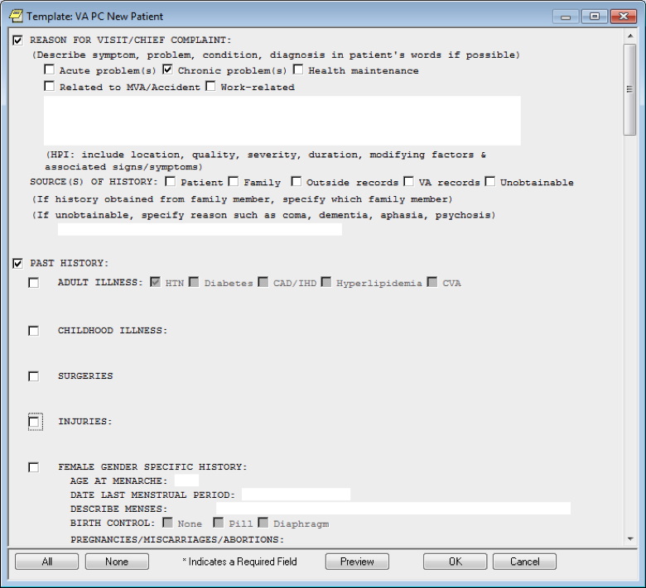

**Figure A.2. VA National Primary Care Note Template: VA Primary Care New Patient - Female Gender Specific History and Social History Section**

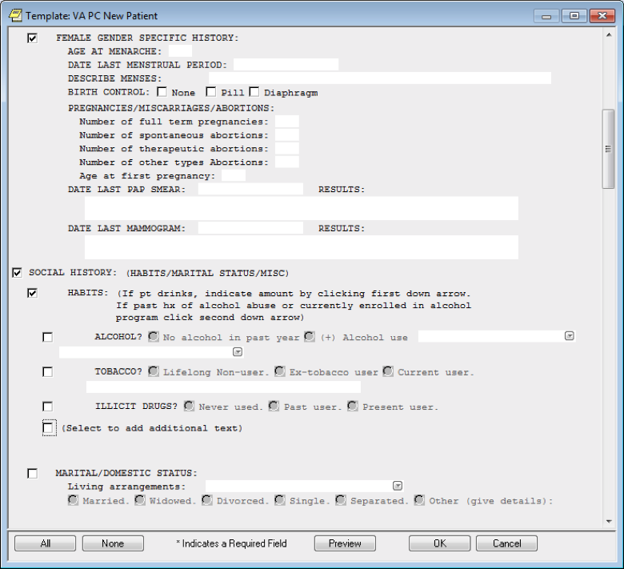

**Figure A.3. VA National Primary Care Note Template: VA Primary Care New Patient - Marital/Domestic Status Section**

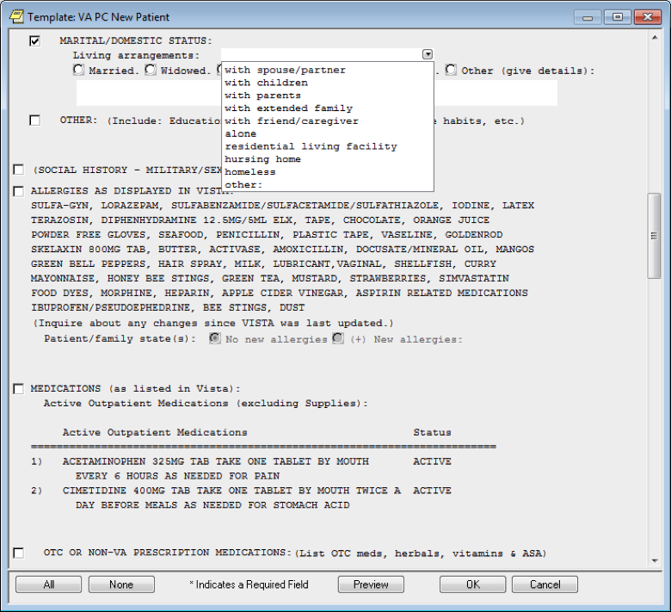

**Figure A.4. VA National Primary Care Note Template: VA Primary Care New Patient - Marital/Domestic Status, Social History and Military History (Branch of Service)**

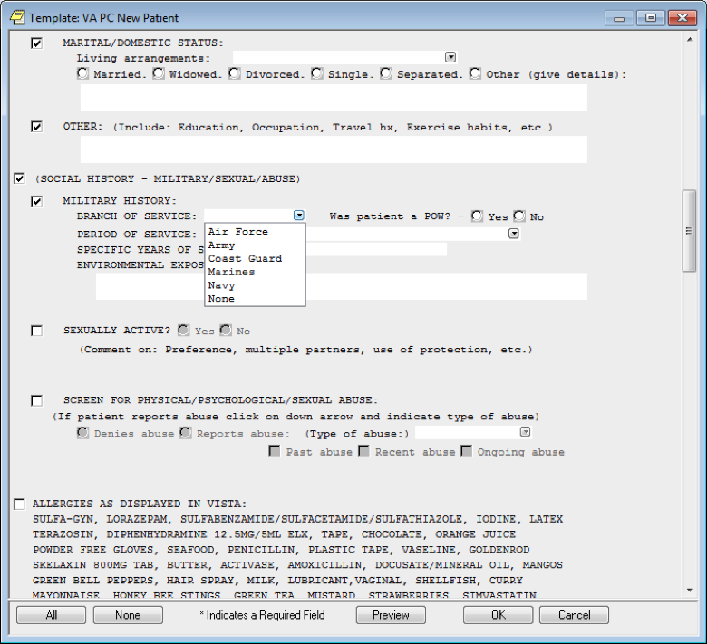

**Figure A.5. VA National Primary Care Note Template: VA Primary Care New Patient - Marital/Domestic Status, Social History and Military History Sections (Period of Service)**

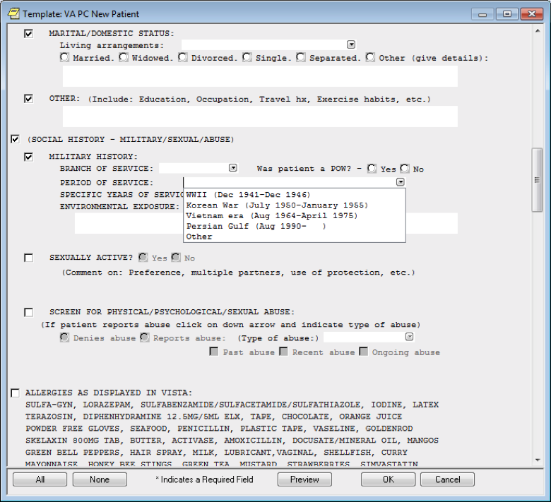

**Figure A.6. VA National Primary Care Note Template: VA Primary Care New Patient - Marital/Domestic Status, Social History, Military History and Screen for Physical/Psychological/Sexual Abuse Sections**

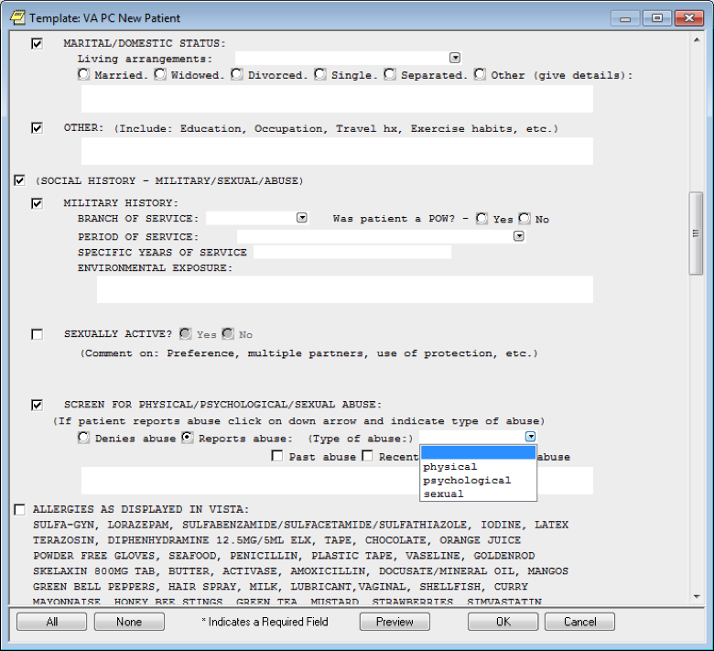

**Figure A.7. VA National Primary Care Note Template: VA Primary Care New Patient - Allergies as Displayed in VistA, Medications, Over the Counter (OTC) or Non-VA Prescription Medications, and Family History Sections**

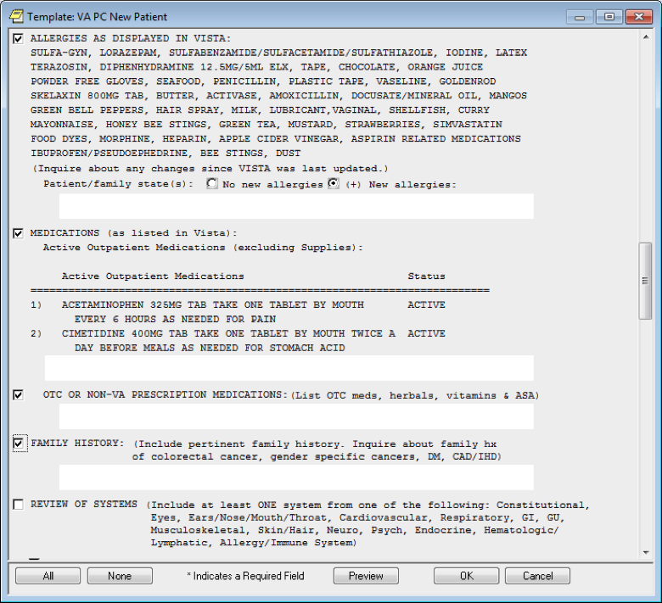

**Figure A.8. VA National Primary Care Note Template: VA Primary Care New Patient - Review of Systems Section**

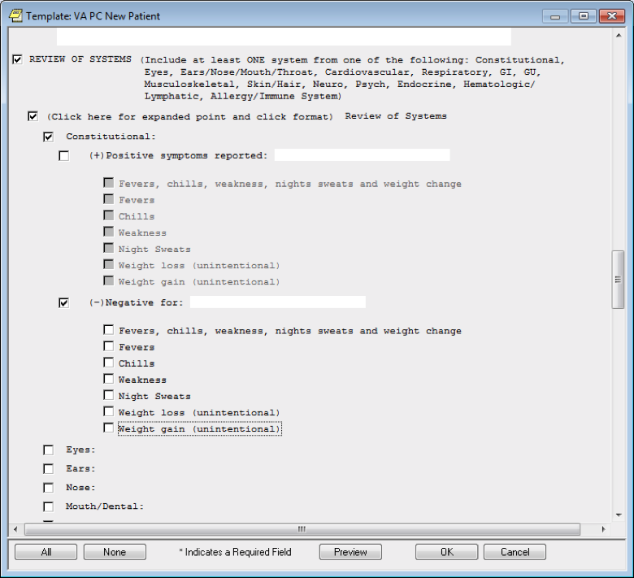

**Figure A.9. VA National Primary Care Note Template: VA Primary Care New Patient - Review of Systems, Eyes Negative for Symptoms Section**

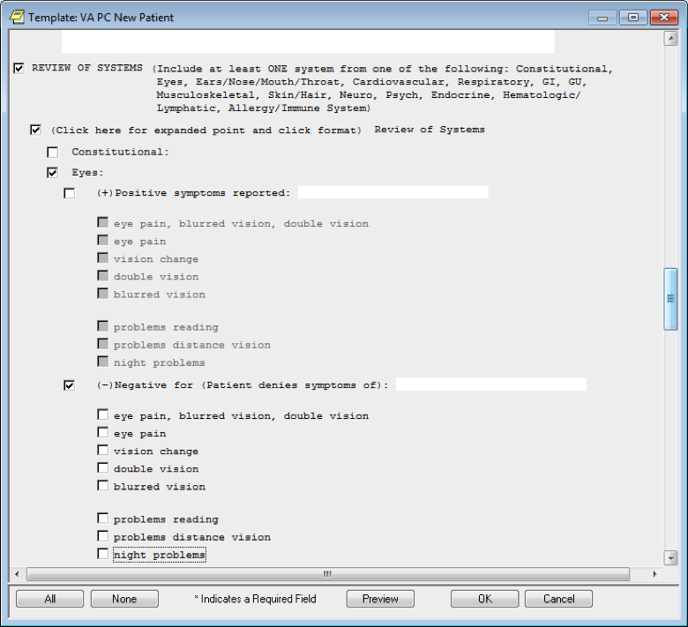

**Figure A.10. VA National Primary Care Note Template: VA Primary Care New Patient - Nose Positive Symptoms Reported Section**

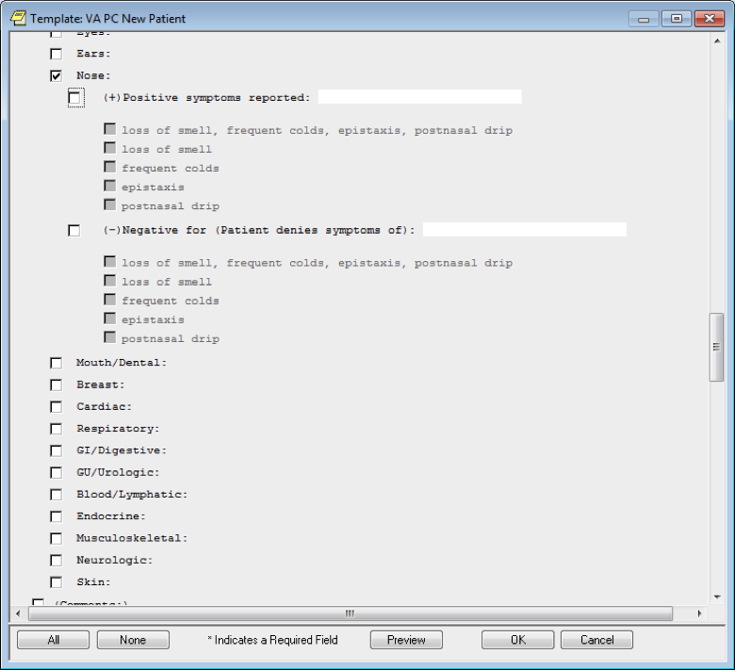

**Figure A.11. VA National Primary Care Note Template: VA Primary Care New Patient - Ears with Positive Symptoms Reported and Negative for Symptoms Sections**

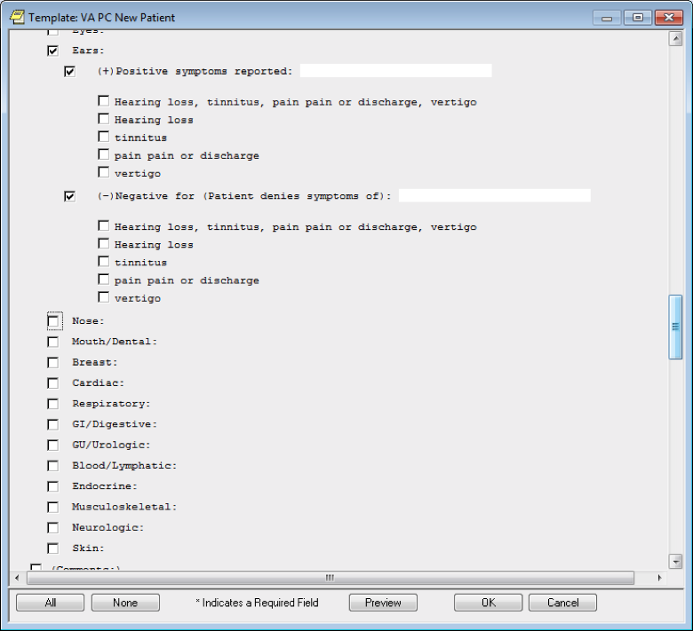

**Figure A.12. VA National Primary Care Note Template: VA Primary Care New Patient - Mouth/Dental Section**

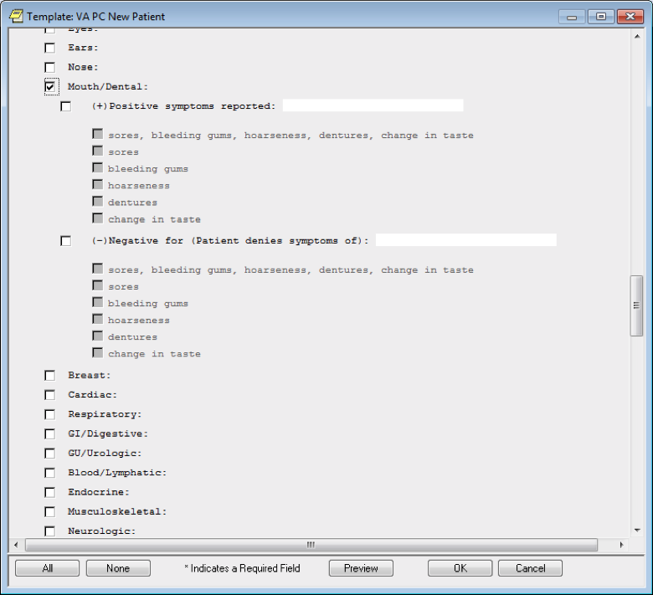

**Figure A.13. VA National Primary Care Note Template: VA Primary Care New Patient - Breast Section**

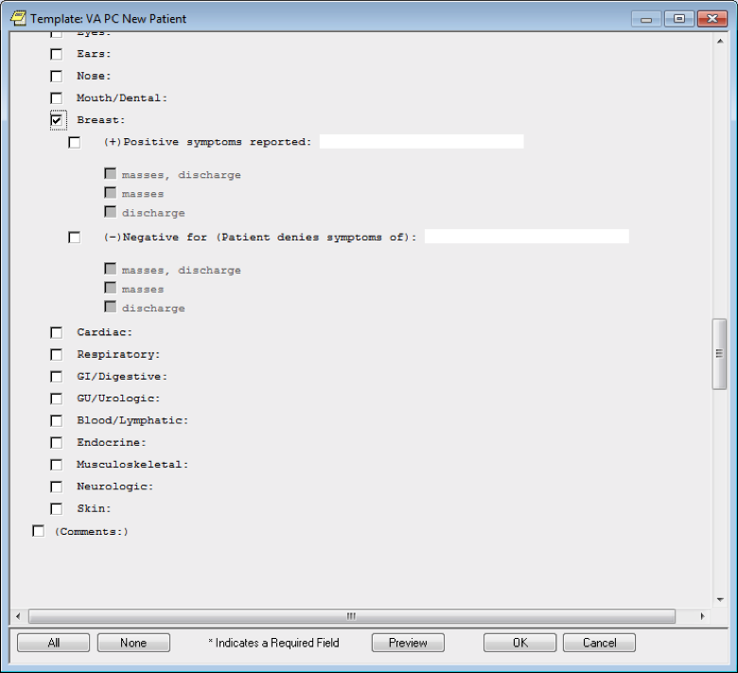

**Figure A.14. VA National Primary Care Note Template: VA Primary Care New Patient - Cardiac Section**

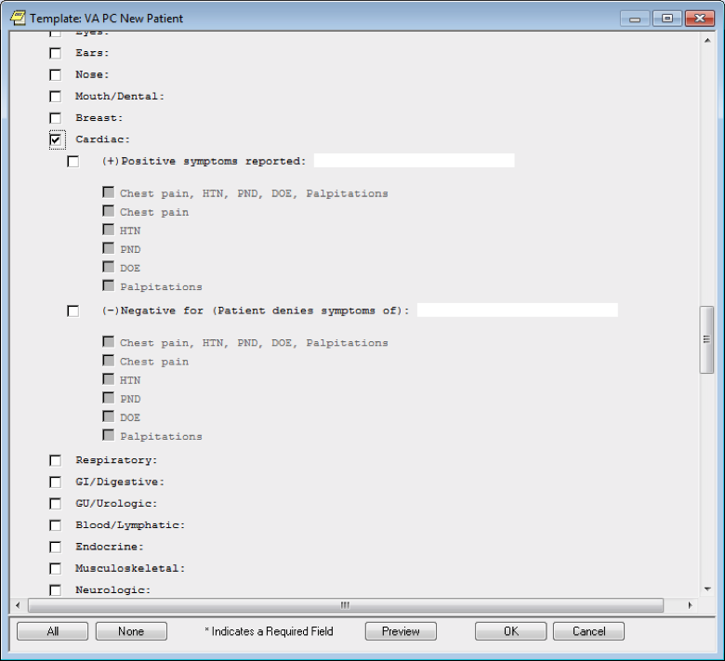

**Figure A.15. VA National Primary Care Note Template: VA Primary Care New Patient - Respiratory Section**

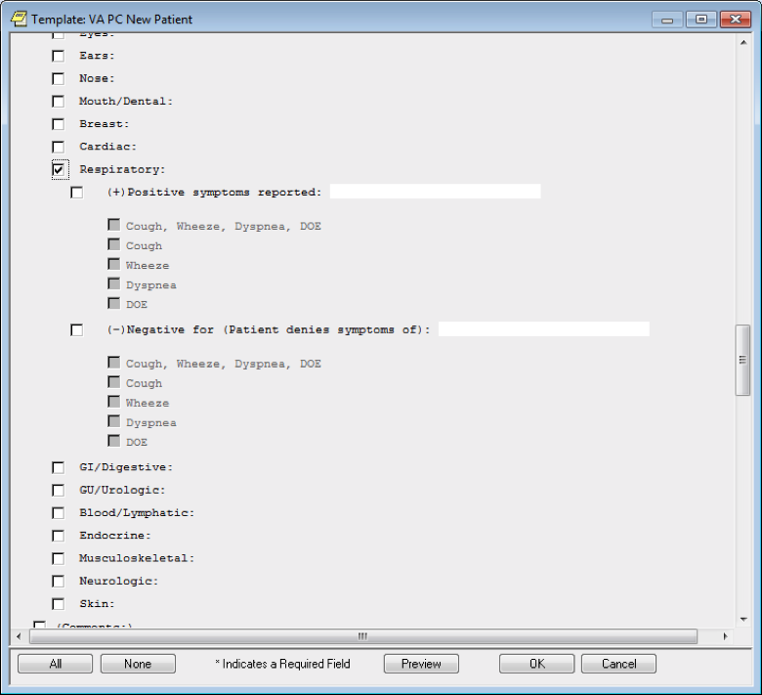

**Figure A.16. VA National Primary Care Note Template: VA Primary Care New Patient - Gastroenterology (GI)/Digestive Section**

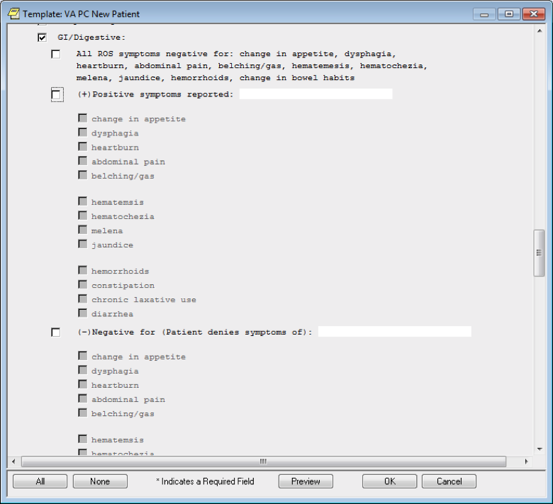

**Figure A.17. VA National Primary Care Note Template: VA Primary Care New Patient - Gastroenterology (GI)/Digestive with Negative for Symptoms Section**

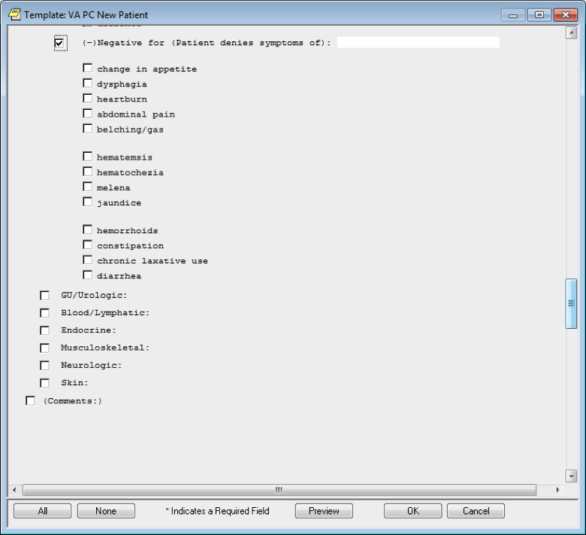

**Figure A.18. VA National Primary Care Note Template: VA Primary Care New Patient - Genitourinary (GU)/Urologic and Male GU Sections**

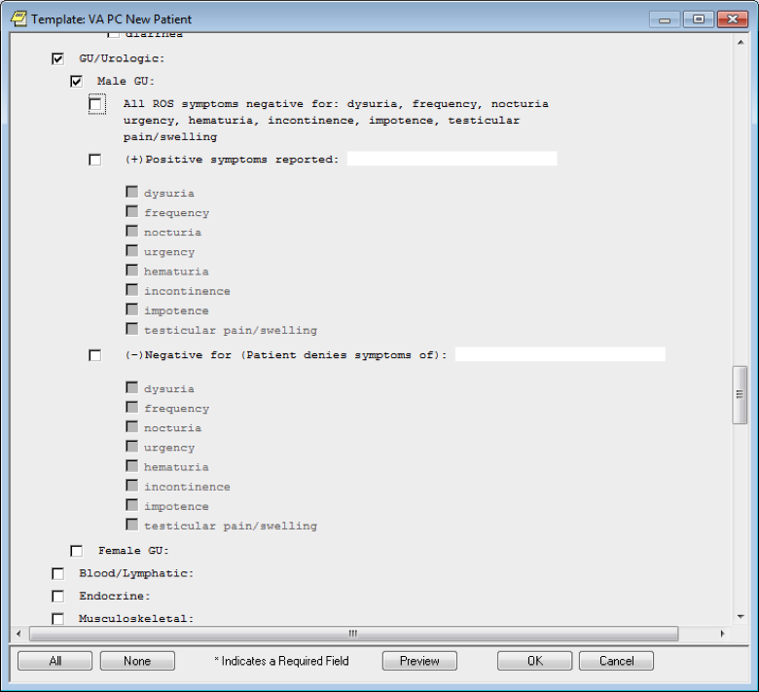

**Figure A.19. VA National Primary Care Note Template: VA Primary Care New Patient - Genitourinary (GU)/Urologic and Female GU Sections**

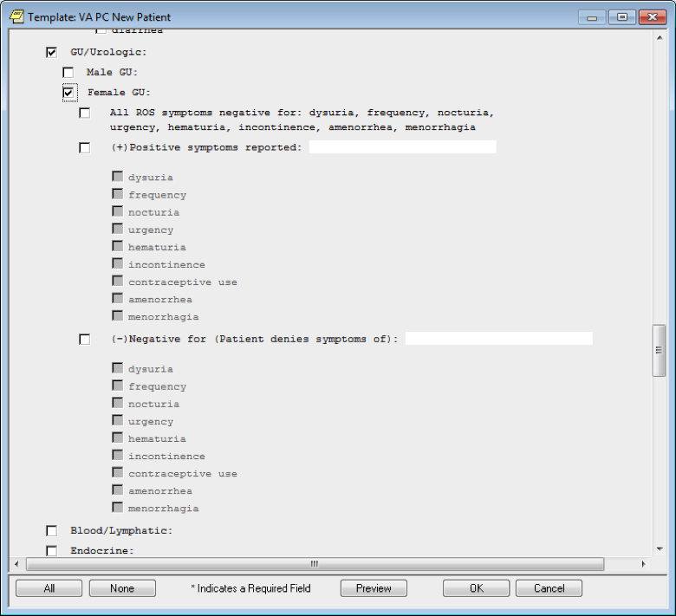

**Figure A.20. VA National Primary Care Note Template: VA Primary Care New Patient - Blood/Lymphatic Section**

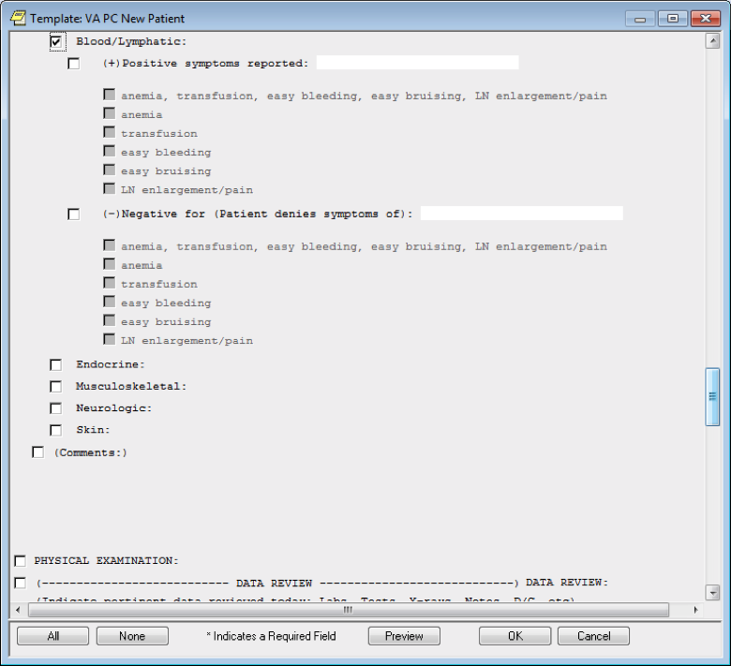

**Figure A.21. VA National Primary Care Note Template: VA Primary Care New Patient - Endocrine Section**

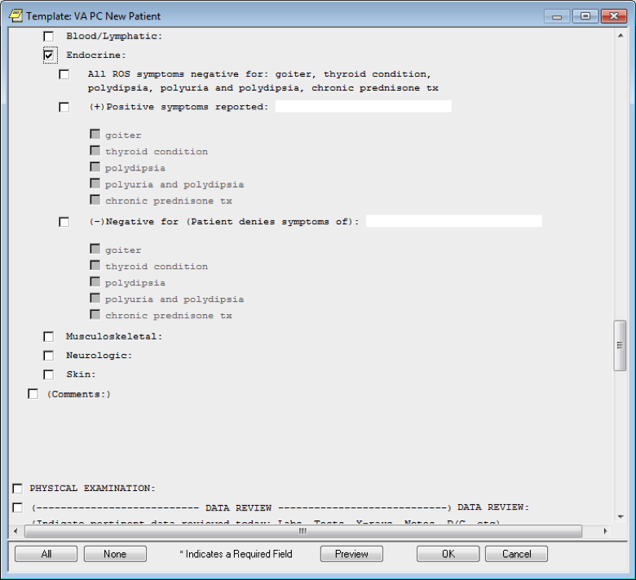

**Figure A.22. VA National Primary Care Note Template: VA Primary Care New Patient - Musculoskeletal Section**

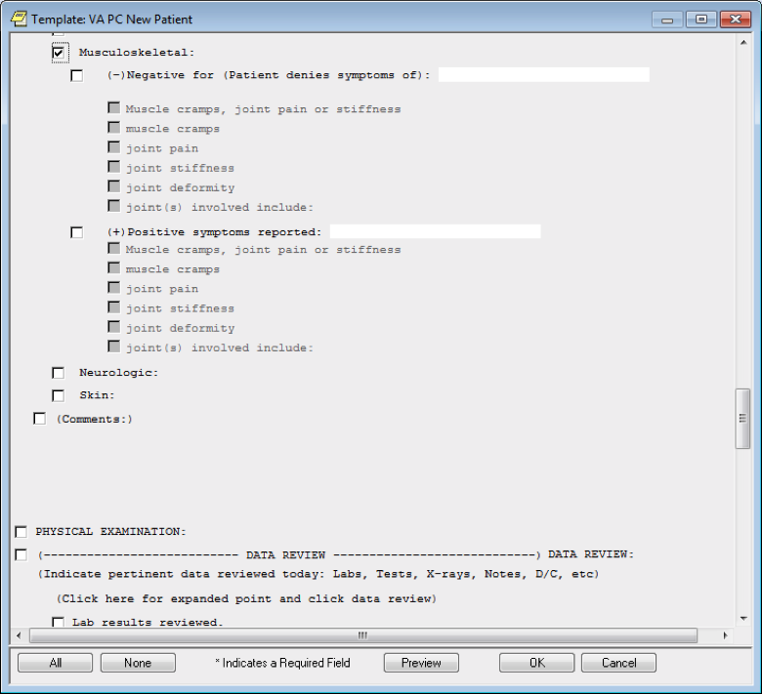

**Figure A.23. VA National Primary Care Note Template: VA Primary Care New Patient - Neurologic Section**

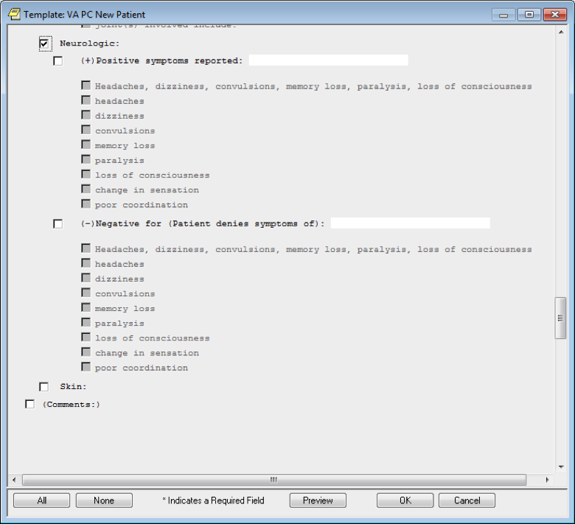

**Figure A.24. VA National Primary Care Note Template: VA Primary Care New Patient - Skin Section**

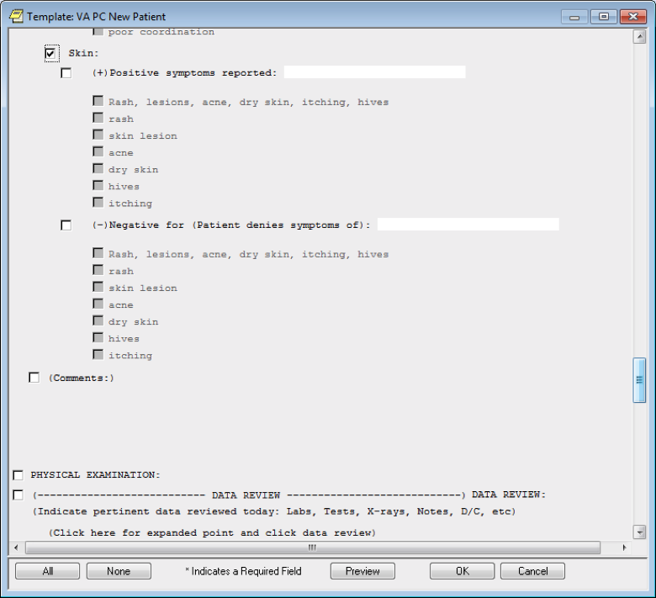

**Figure A.25. VA National Primary Care Note Template: VA Primary Care New Patient - Skin Section with Added Comments**

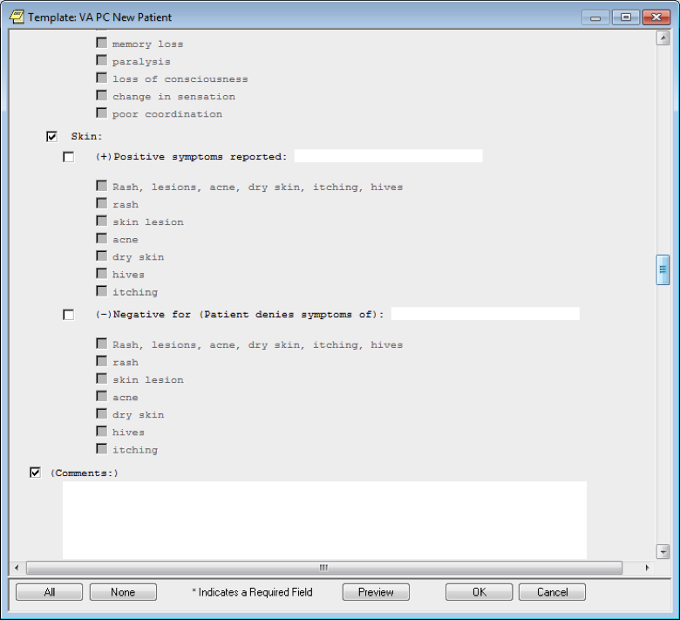

**Figure A.26. VA National Primary Care Note Template: VA Primary Care New Patient - Physical Examination and Eye Exam Sections**

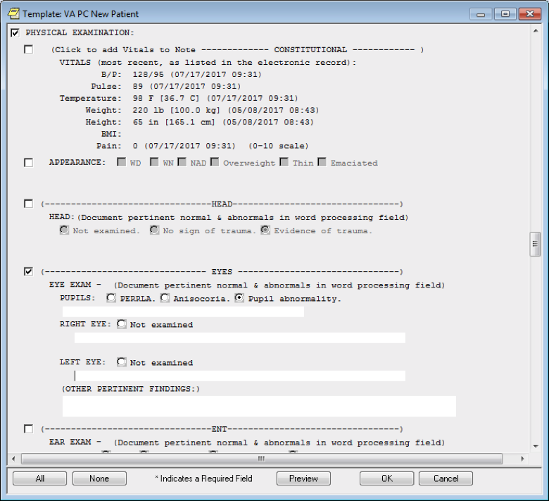

**Figure A.27. VA National Primary Care Note Template: VA Primary Care New Patient - Ear, Nose, and Throat (ENT), Neck, and Chest Sections**

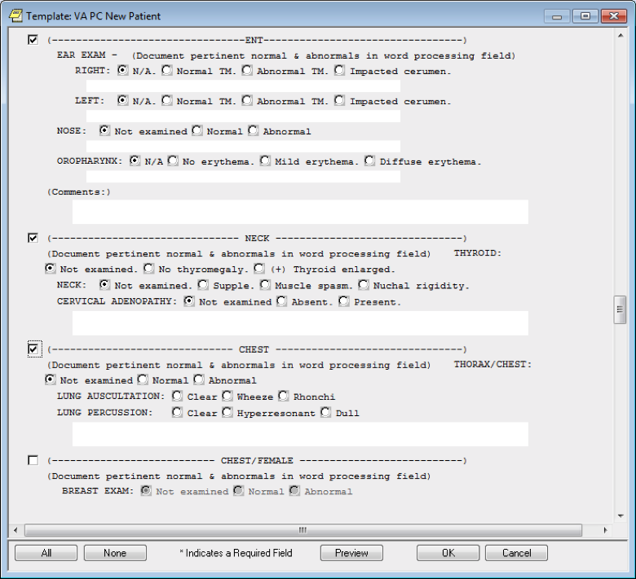

**Figure A.28. VA National Primary Care Note Template: VA Primary Care New Patient - Chest/Female and Cardiovascular Sections**

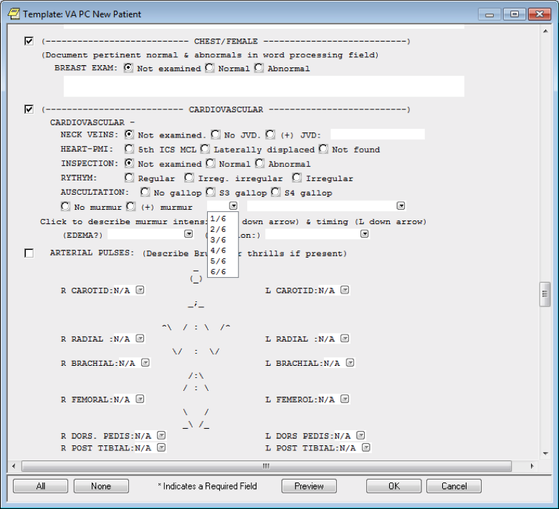

**Figure A.29. VA National Primary Care Note Template: VA Primary Care New Patient - Chest/Female and Cardiovascular Sections - specifying Auscultation Murmur Drop-down**

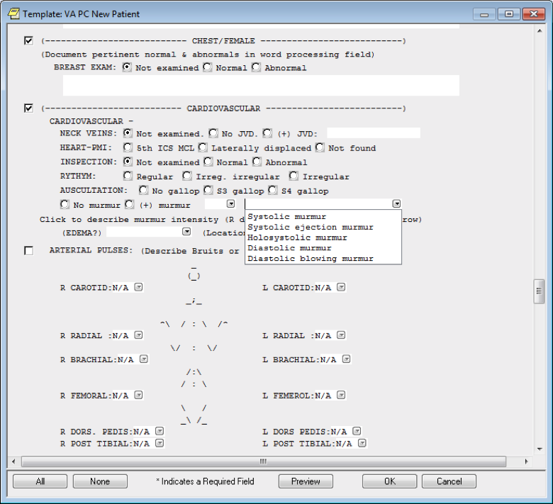

**Figure A.30. VA National Primary Care Note Template: VA Primary Care New Patient - Chest/Female and Cardiovascular Sections - Specifying Edema Drop-down**

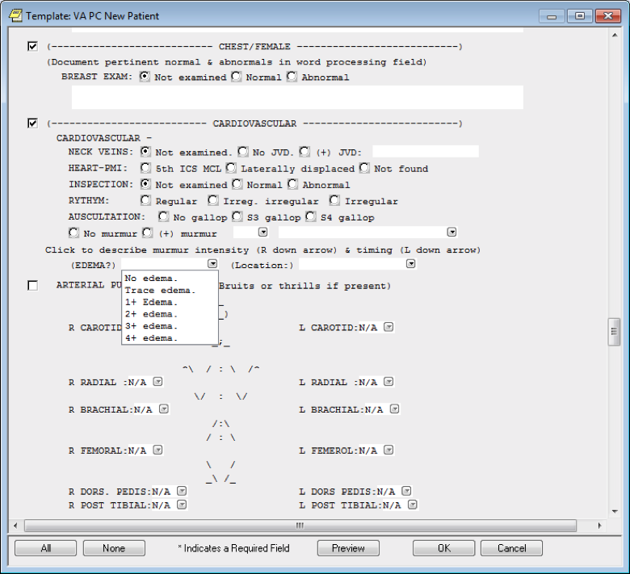

**Figure A.31. VA National Primary Care Note Template: VA Primary Care New Patient - Chest/Female and Cardiovascular Sections, Specifying Edema Location**

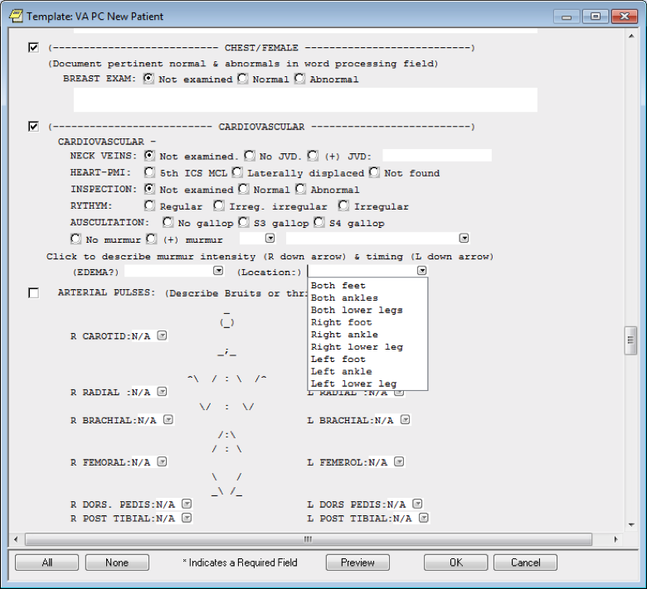

**Figure A.32. VA National Primary Care Note Template: VA Primary Care New Patient - Arterial Pulses, R Carotid Section**

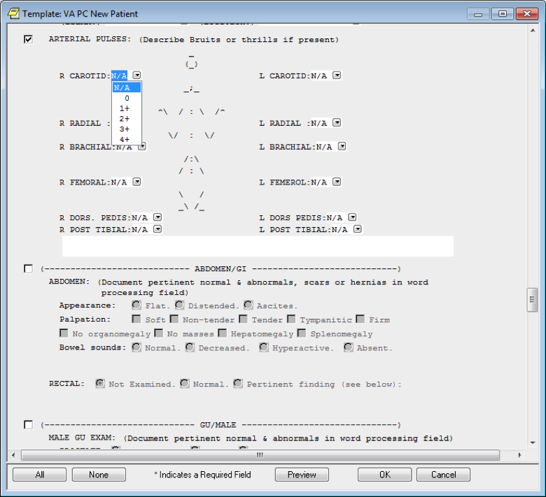

**Figure A.33. VA National Primary Care Note Template: VA Primary Care New Patient - Extremities, Musculoskeletal, and Deep Tendon Reflexes Sections**

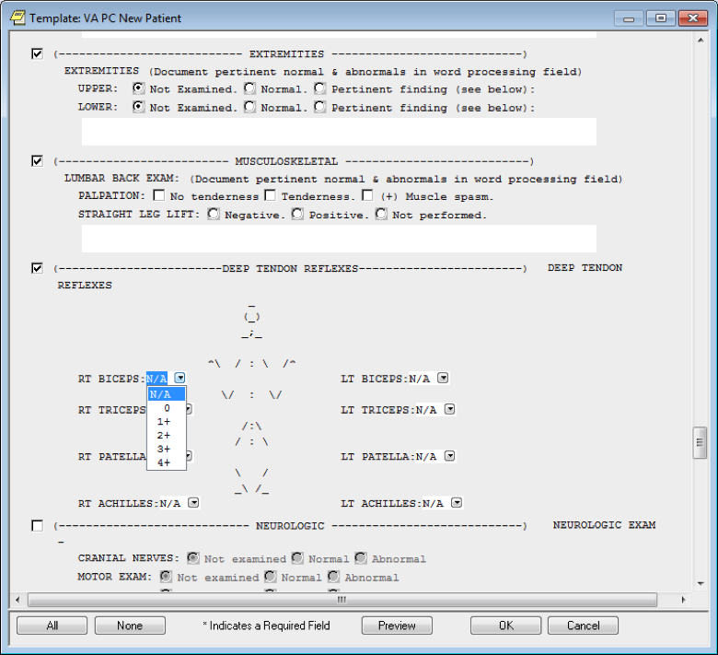

**Figure A.34. VA National Primary Care Note Template: VA Primary Care New Patient - Abdomen/Gastroenterology (GI), Genitourinary (GU)/Male, and GU/Female Sections**

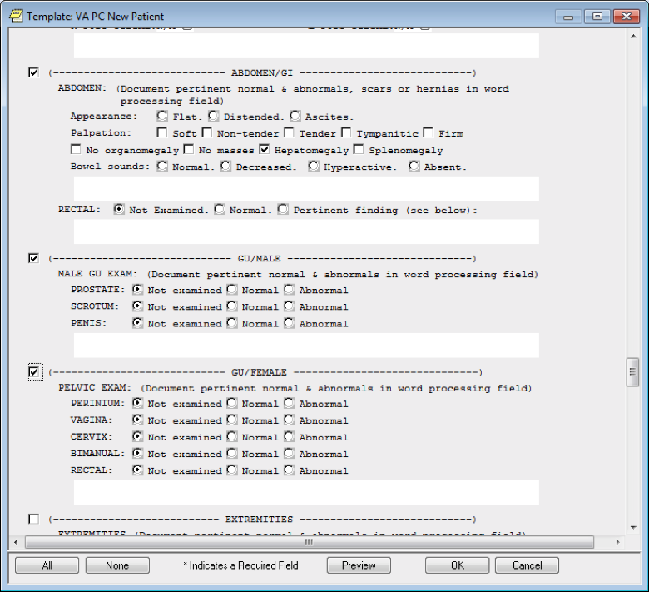

**Figure A.35. VA National Primary Care Note Template: VA Primary Care New Patient - Neurologic, Lymphatics, Dermatology, and Psychiatric Sections**

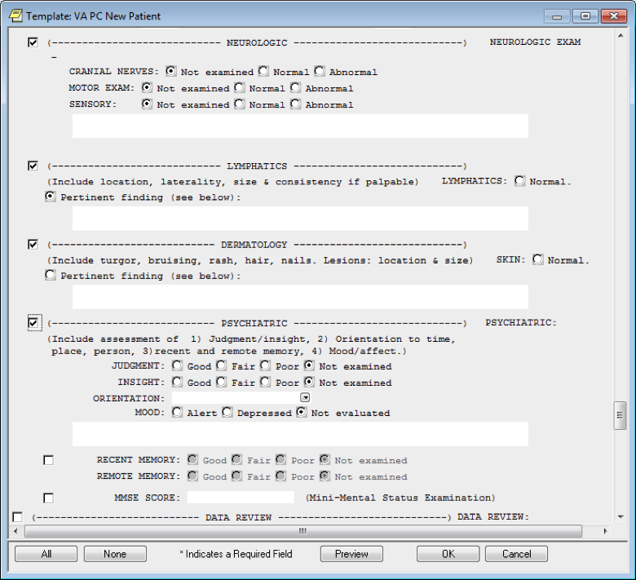

**Figure A.36. VA National Primary Care Note Template: VA Primary Care New Patient - Psychiatric, Data including Lab Results Reviewed**

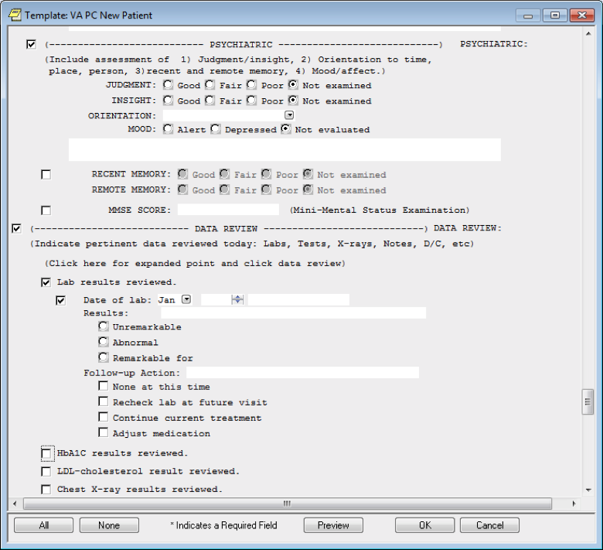

**Figure A.37. VA National Primary Care Note Template: VA Primary Care New Patient - HbA1c and Low-density lipoprotein (LDL)-cholesterol Results Reviewed**

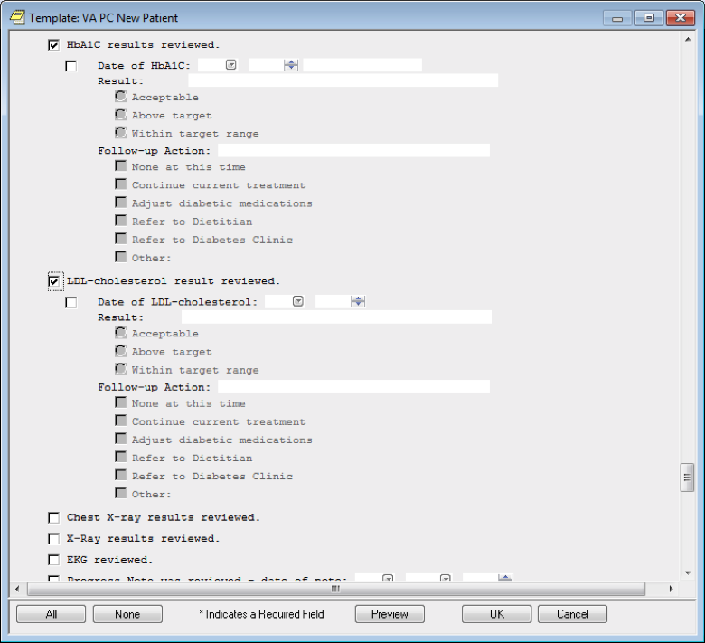

**Figure A.38. VA National Primary Care Note Template: VA Primary Care New Patient - X-ray Results Reviewed**

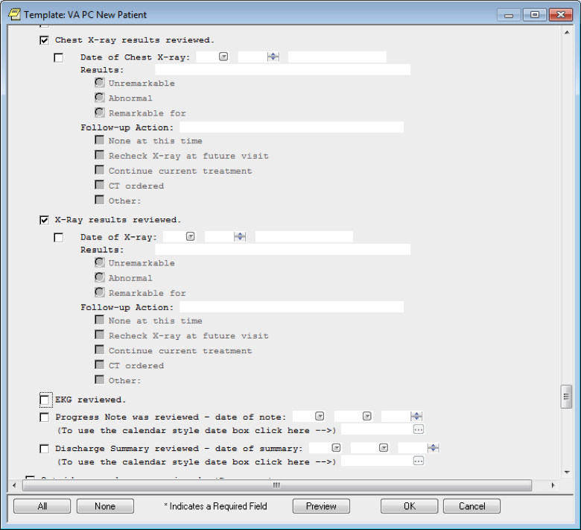

**Figure A.39. VA National Primary Care Note Template: VA Primary Care New Patient – Electrocardiogram (EKG) Reviewed**

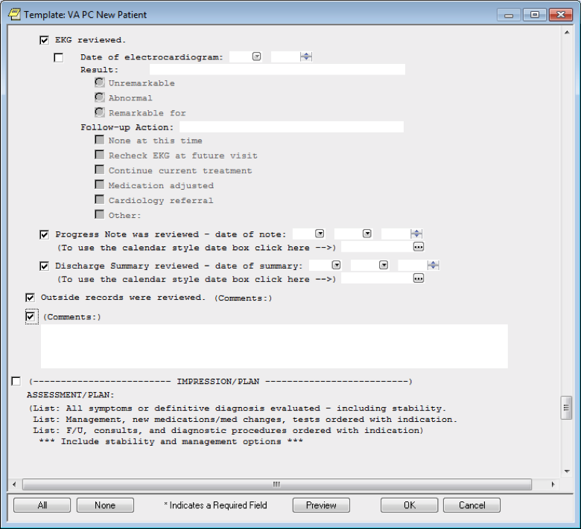

**Figure A.40. VA National Primary Care Note Template: VA Primary Care New Patient - Impression/Plan**

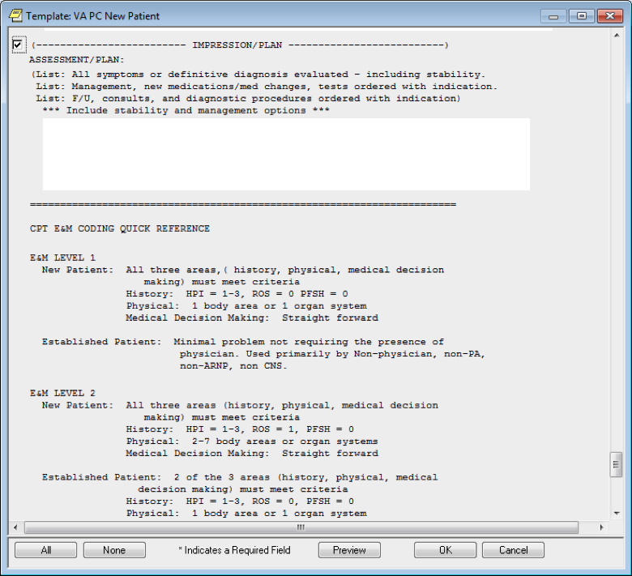

**Figure A.41. VA National Primary Care Note Template: VA Primary Care New Patient - Evaluation and Management (E & M) Levels 3-5**

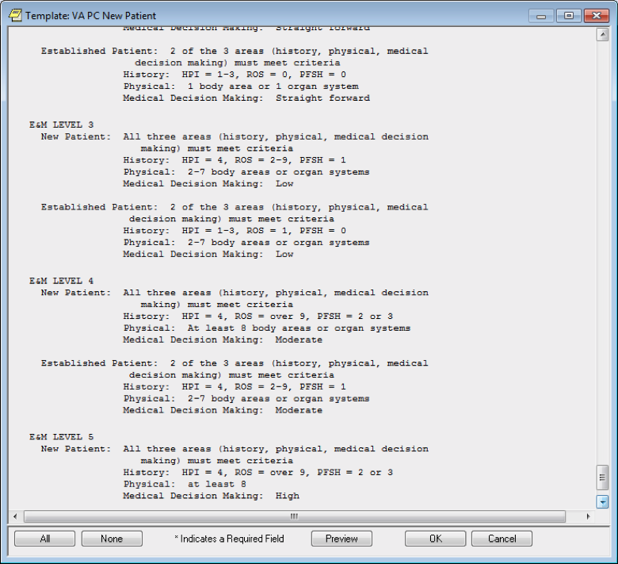

**Figure A.42. VA National Primary Care Note Template: VA Primary Care New Patient – Evaluation and Management (E & M) Level 5: Established Patients**

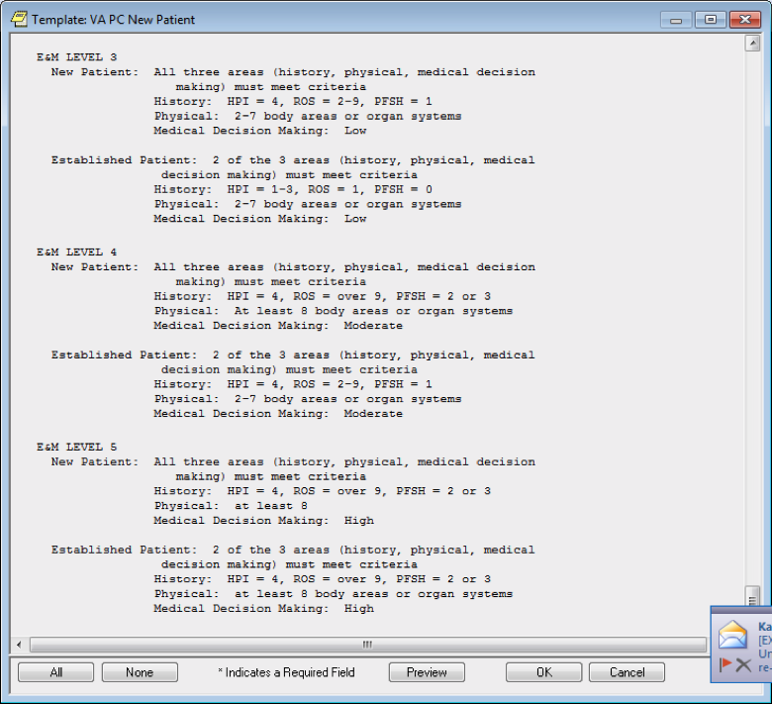

**Figure A.43. VA National Primary Care Note Template: VA Primary Care Clinical Reminder Resolution Assessing Care of Vulnerable Elders (ACOVE) Functional Status**

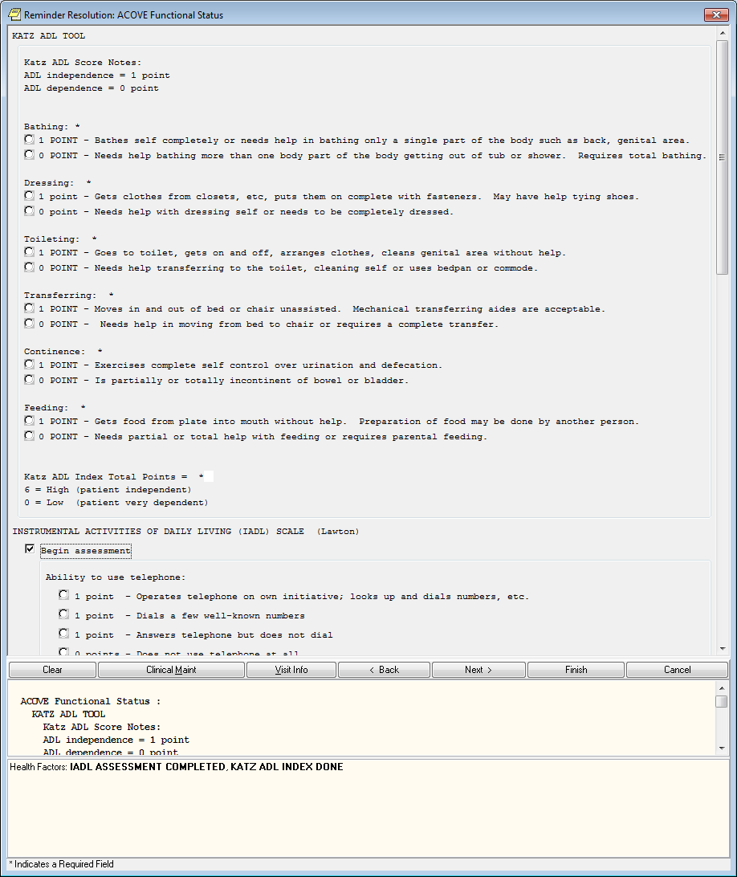

**Appendix B. Basic Laboratory Panel Definition**

* Blood Urea Nitrogen
* Calcium
* Chloride
* CO2 (Carbon Dioxide, Bicarbonate)
* Creatinine
* Glucose
* Potassium
* Sodium

**Acronyms**

|  |  |
| --- | --- |
| **Acronym** | **Definition** |
| ACOVE | Assessing Care of Vulnerable Elders |
| BMI | Body Mass Index |
| BP | Blood Pressure |
| BPM | Beats Per Minute |
| CCWP | Clinical Content White Paper |
| CDS | Clinical Decision Support |
| CO2 | Carbon Dioxide |
| DoD | Department of Defense |
| E&M | Evaluation and Management |
| EKG | Electrocardiogram |
| ENT | Ears, Nose, Throat |
| GI | Gastroenterology |
| GU | Genitourinary |
| HEENT | Head, Eyes, Ears, Nose, Throat |
| HL7 | Health Level 7 |
| KBS | Knowledge Based Systems |
| KNART | Knowledge Artifact |
| LDL | Low-density Lipoprotein |
| OIIG | Office of Informatics and Information Governance |
| OTC | Over the Counter |
| PTSD | Post-Traumatic Stress Disorder |
| SME | Subject Matter Expert |
| TO | Task Order |
| USPSTF | United States Preventive Services Task Force |
| VA | Department of Veterans Affairs |
| VACO | VA Central Office |
| VAMC | VA Medical Center |